Practical:2.3
Practical Title
Exploration of Drawable and Dimension Resources in Android
Aim
To study and implement Drawable and Dimension resources in an Android application for designing a visually consistent and well-spaced user interface.
Problem Statement
To design and develop a simple Android application named “College Notice Board App” that demonstrates the use of drawable and dimension resources.

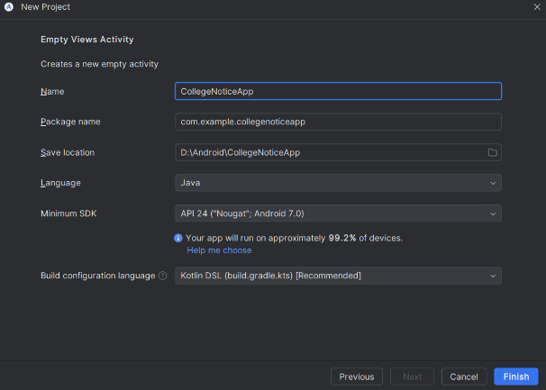
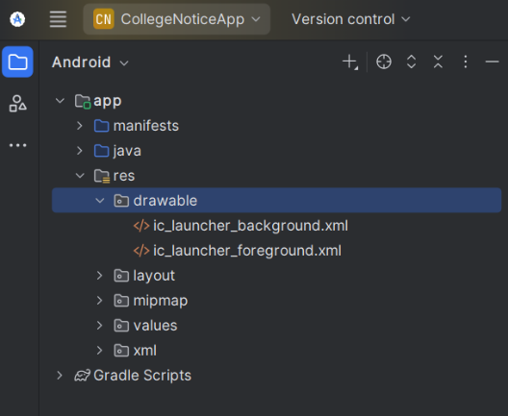
PRACTICAL: Drawable & Dimension Resources (TCSC)
STEP 1: Open Android Studio
- Click New Project
STEP 2: Select Project Template
- Choose Empty Views Activity
- Click Next
STEP 3: Configure Your Project
Fill exactly like this:
Field | Value
Name | CollegeNoticeApp
Package name | com.example.collegenoticeapp
Save location | Default
Language | Java
Minimum SDK | API 21 (Android 5.0)
Build configuration language | Default
Click Finish
Wait until Gradle build completes.
STEP 4: Add Image (Drawable Resource)
- Copy your image logo.jpg
- Go to:
app → src → main → res → drawable
- Paste logo.jpg inside drawable
No renaming required
STEP 5: Create Dimension Resources
Open:
res → values → dimens.xml
If not present:
- Right-click values
- New → Values Resource File
- Name: dimens
<?xml version="1.0" encoding="utf-8"?>
<resources>
<dimen name="logo_size">120dp</dimen>
<dimen name="padding_large">16dp</dimen>
<dimen name="padding_medium">12dp</dimen>
<dimen name="text_large">20sp</dimen>
<dimen name="text_medium">16sp</dimen>
</resources>

STEP 6: Edit Layout File
Open:
res → layout → activity_main.xml
Replace entire code with this:
<?xml version="1.0" encoding="utf-8"?>
<LinearLayout xmlns:android="http://schemas.android.com/apk/res/android"
android:layout_width="match_parent"
android:layout_height="match_parent"
android:orientation="vertical"
android:gravity="center"
android:padding="@dimen/padding_large">

<ImageView
android:layout_width="@dimen/logo_size"
android:layout_height="@dimen/logo_size"
android:src="@drawable/logo"
android:contentDescription="College Logo"
android:layout_marginBottom="@dimen/padding_medium" />

<TextView
android:layout_width="wrap_content"
android:layout_height="wrap_content"
android:text="TCSC"
android:textSize="@dimen/text_large"
android:layout_marginBottom="@dimen/padding_medium" />

<TextView
android:layout_width="wrap_content"
android:layout_height="wrap_content"
android:text="College Notice Board"
android:textSize="@dimen/text_medium" />
</LinearLayout>
STEP 7: Java File
Open:
java → com.example.collegenoticeapp → MainActivity.java
Default code is sufficient:
package com.example.collegenoticeapp;
import android.os.Bundle;
import androidx.appcompat.app.AppCompatActivity;
public class MainActivity extends AppCompatActivity {
@Override
protected void onCreate(Bundle savedInstanceState) {
super.onCreate(savedInstanceState);
setContentView(R.layout.activity_main);
}
}
STEP 8: Run the Application
- Click Run

